National University of Computer and Emerging Sciences


Lab Manual 4
“Introduction to DDL-DML and Constraints through SQL script”
Database Systems
Spring 2016

Department of Computer Science
FAST-NU, Lahore, Pakistan

Table of Contents
1. Objective 2
2. Task Distribution 2
3. DDL 3
4. DML 3
5. DCL 3
6. TCL 3
7. Required Material: 4
8. Creating Table 4
9. Drop/ Truncate 8
10. Insert/Select/Update 10
11. Delete 15
12. Primary Key/ Identity Column 17
13. Foreign Key 26
14. EXERCISE : 32

Objective
The purpose of this lab activity is to familiarize you with the concept of DDL commands, what are DDL commands, how to play around with them.

Task Distribution

Total Time | 130 Minutes
SQL Server DMBS Review | 20 Minutes
Table Creation | 25 Minutes
DDL | 25Minutes
Exercise | 60 Minutes

DDL
Data Definition Language (DDL) statements are used to define the database structure or schema. Some examples:
- CREATE - to create objects in the database
- ALTER - alters the structure of the database
- DROP - delete objects from the database
- TRUNCATE - remove all records from a table, including all spaces allocated for the records are removed

DML
Data Manipulation Language (DML) statements are used for managing data within schema objects. Some examples:
- SELECT - retrieve data from the a database
- INSERT - insert data into a table
- UPDATE - updates existing data within a table
- DELETE - deletes all records from a table, the space for the records remain

DCL
Data Control Language (DCL) statements. Some examples:
- GRANT - gives user's access privileges to database
- REVOKE - withdraw access privileges given with the GRANT command

TCL
Transaction Control (TCL) statements are used to manage the changes made by DML statements. It allows statements to be grouped together into logical transactions.
- COMMIT - save work done
- SAVEPOINT - identify a point in a transaction to which you can later roll back
- ROLLBACK - restore database to original since the last COMMIT

Required Material:
The SQL scripts are also placed along with this file.

Creating Table

Task 1: Creating table using SQL server management studio designer | Estimated completion time (mins): 30
Step 1: Open SQL server management studio

- Start->Program Files ->SQL server 2008 -> SQL server management studio
- Enter your server name as “cactus” username as “lab” password as “123456789”
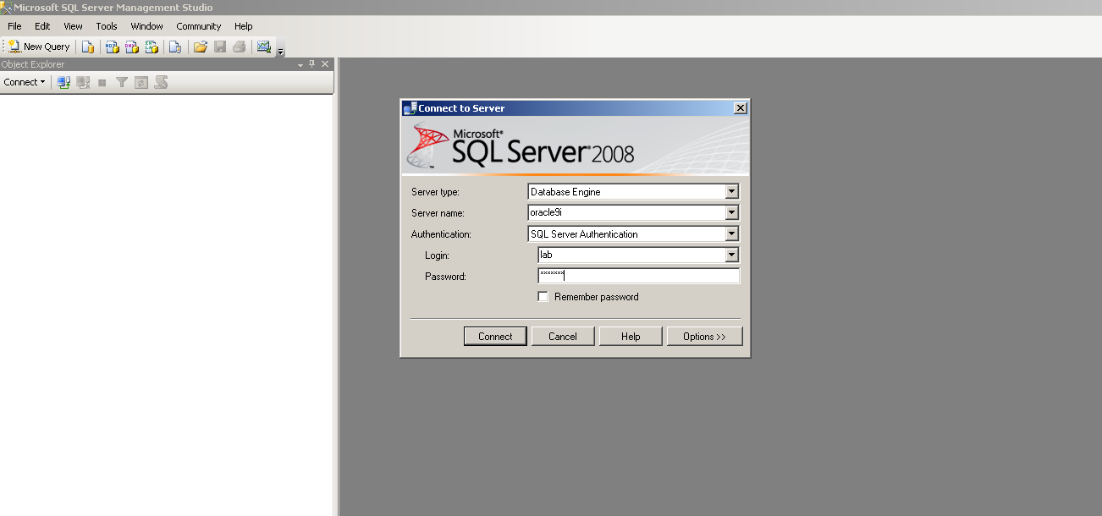
- Select your database
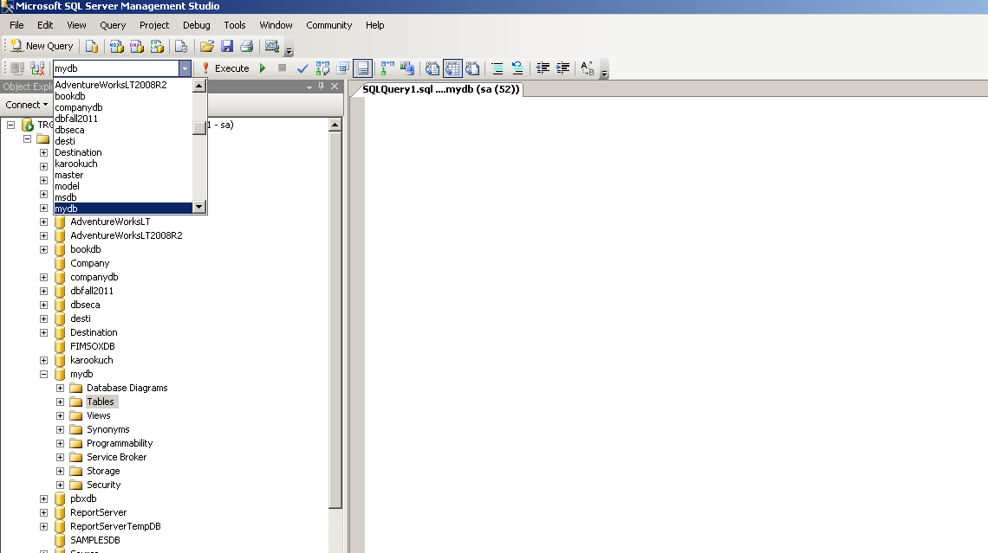
Step 2: Creating Table through script
- Create New Schema and Table. Open Query Manger and create scheme with the name of lab4 and generate tables School and Staff in lab 4 schema with the different attributes mentioned in the below picture.

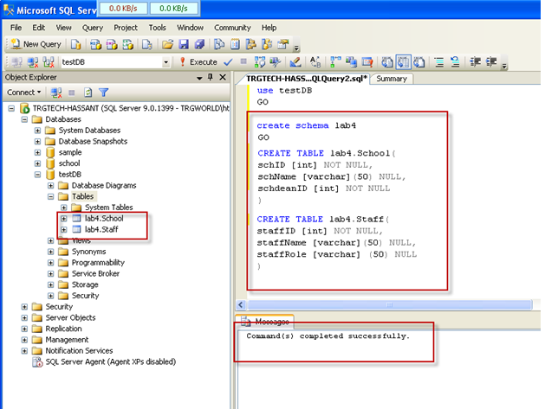

Task 2: ALTER table using SQL server management studio designer | Estimated completion time (mins): 10
Step 1: ALTER Table through script
  - Adding column through ALTER statement; Add new Column in ‘School’ table by using the ‘Add’ command.
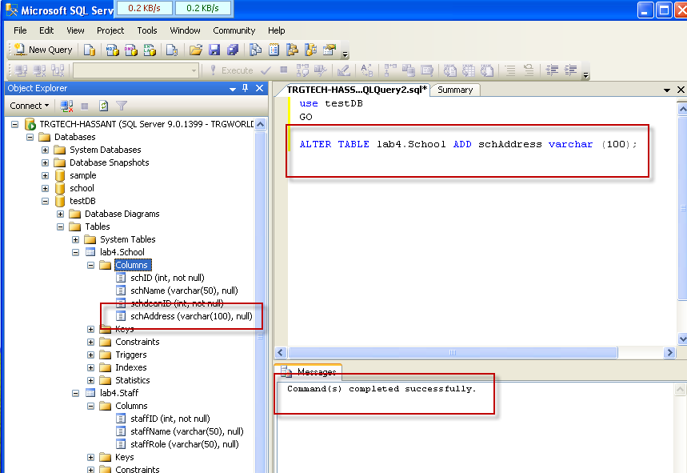

  - Removing column through “Drop” in ALTER statement.

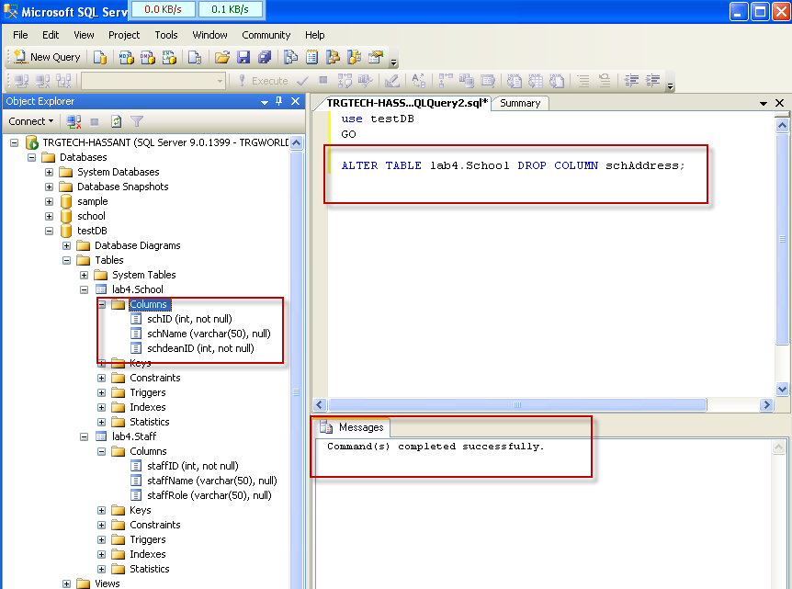

Drop/ Truncate
Task 3: DROP/TRUNCATE table using SQL server management studio designer | Estimated completion time (mins): 10
Step 1: Drop Table through script

- The DROP command removes a table from the database. All the tables' rows, indexes and privileges will also be removed.
Drop Table syntax:

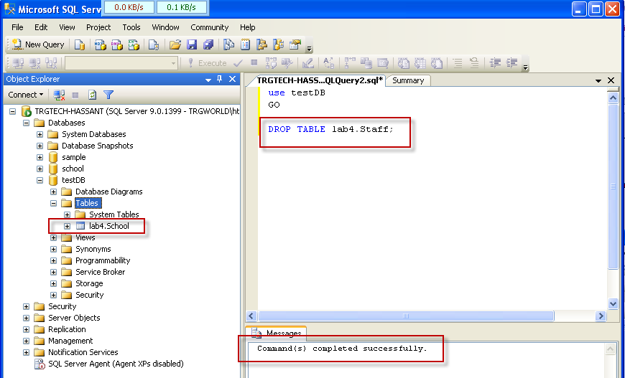

Step 2: Truncate Table through script
- TRUNCATE removes all rows from a table while structures still persists.
TRUNCATE Table

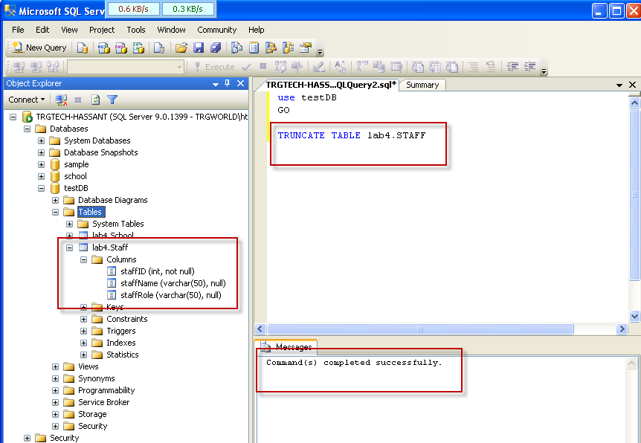

Insert/Select/Update

Task 4: INSERT table using SQL server management studio designer | Estimated completion time (mins): 15
Step 1: INSERT Table through script

- INSERT Table (Save all data after typing below statement);. Insert different values in previously defined columns of School and Staff table by using the following syntax.

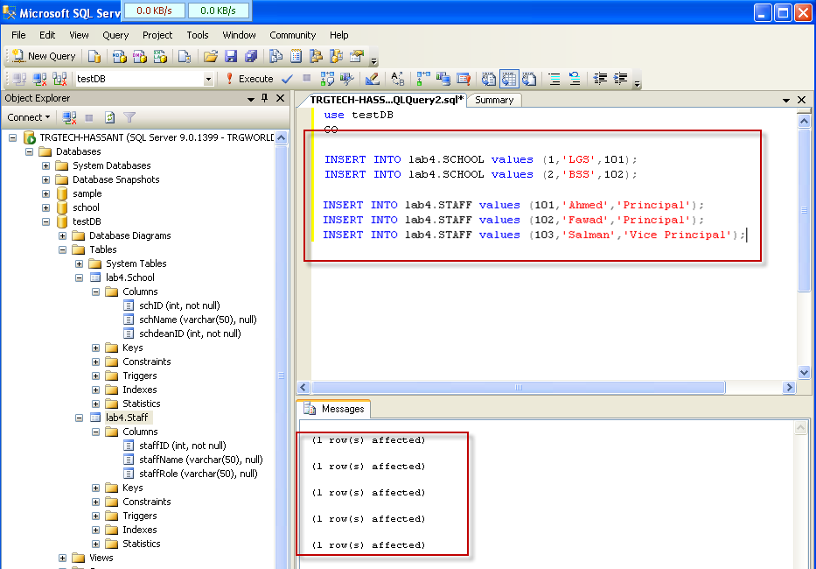

Step 2: INSERT in Specific Column

  - INSERT Table in specified column; Insert Values in their respective columns of Staff table.
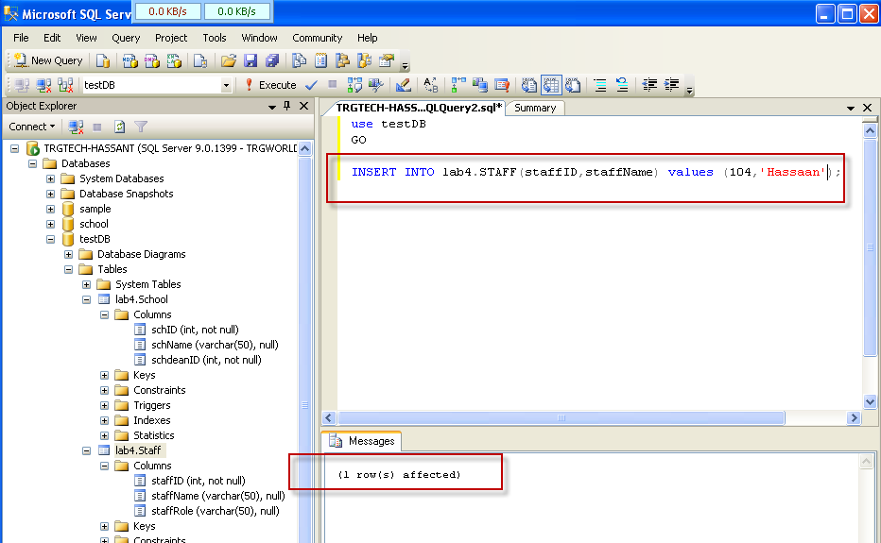

Step 3: SELECT Table through script

  - SELECT Table; ‘Select’ Keyword is used for different column selections in specified table name after the ‘from’ keyword. Here ‘*’ means all columns. You can also mention required column names separated by comma after the select keyword.
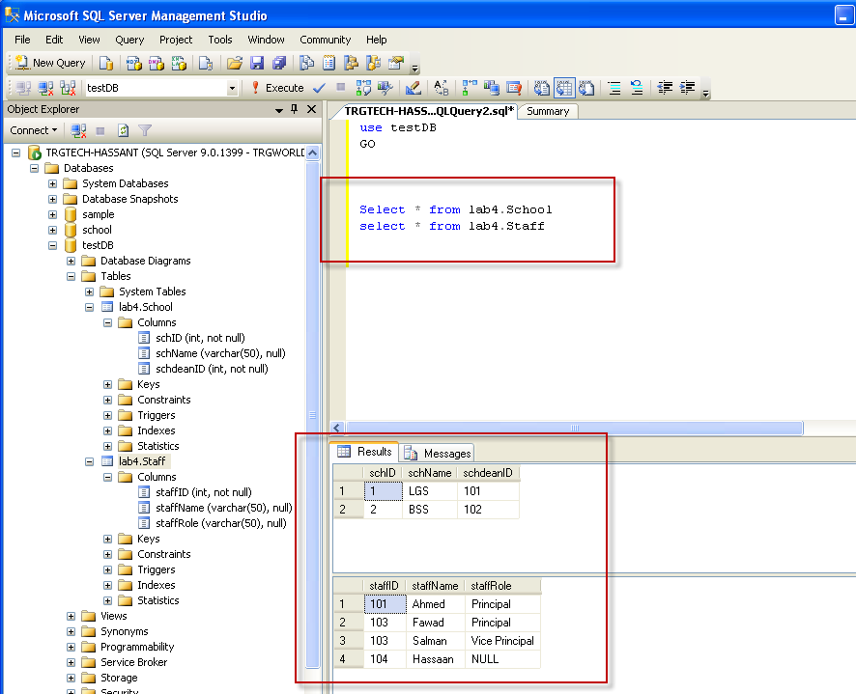

Task 5: UPDATE table using SQL server management studio designer | Estimated completion time (mins): 15
Step 1: UPDATE Table through script

- UPDATE Table; ’Update’ keyword is used for updating the different values in columns. ‘Set’ keyword is used to assign the updated value to any given column whereas ‘where’ is used for condition on some certain value.

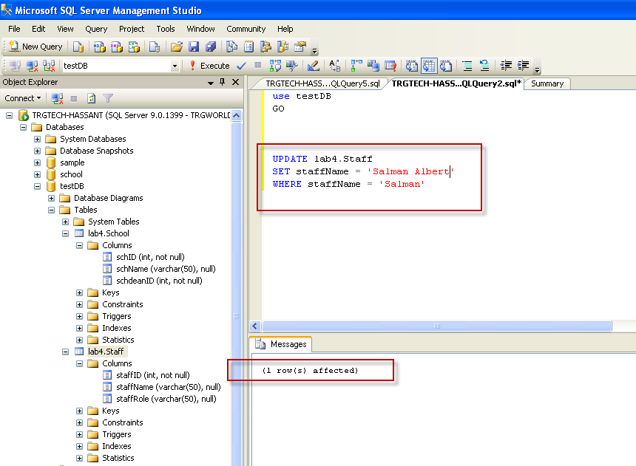

Step 2: SELECT Table through script

  - SELECT Table

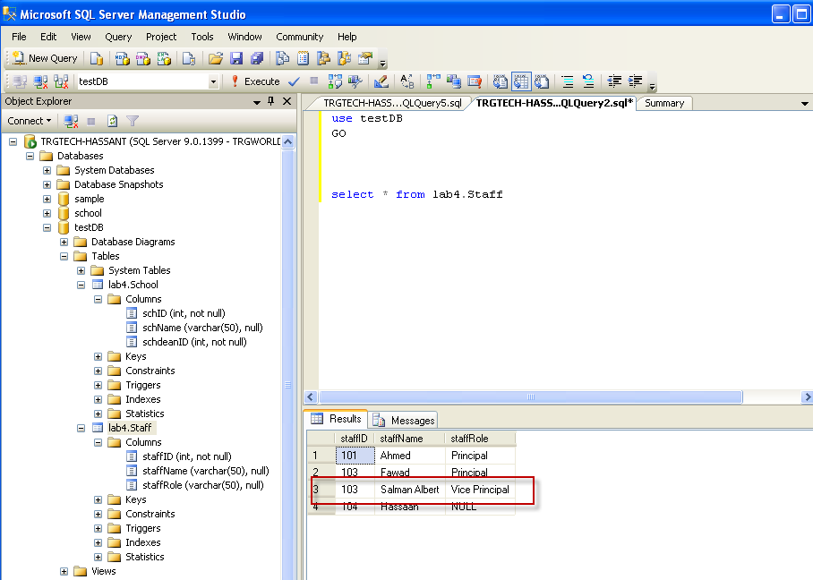

Step 3: UPDATE without WHERE clause will update all records in a table

Delete

Task 6: DELETE using SQL server management studio designer | Estimated completion time (mins): 15
Step 1: DELETE through script
- DELETE row; ‘Delete’ keyword is used to delete row(s) which satisfy the mentioned condition on given column. You can apply condition on more than one column as well by using the ‘and’ keyword.
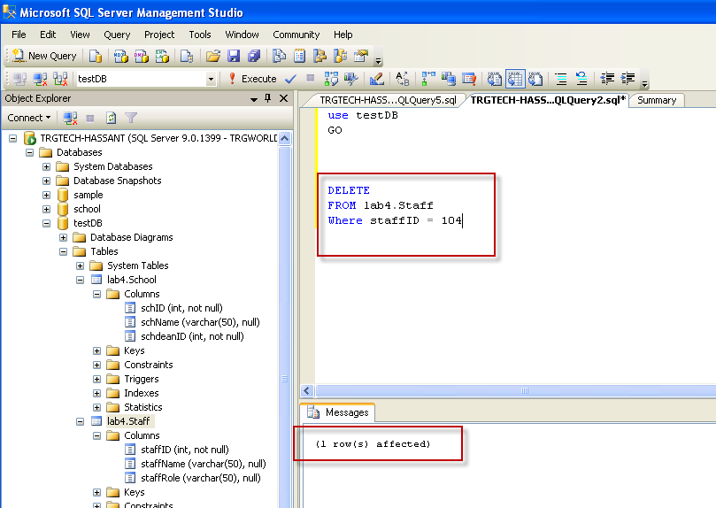

Step 2: SELECT Table through script
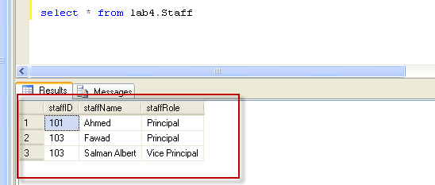

Step 2: DELETE without WHERE clause will delete all records in a table

Primary Key/ Identity Column

Task 7: SET PRIMARY KEY using SQL server management studio designer | Estimated completion time (mins): 20
Step 1: PRIMARY KEY through Designer
- Right Click on School Table and Click on “DESIGN”
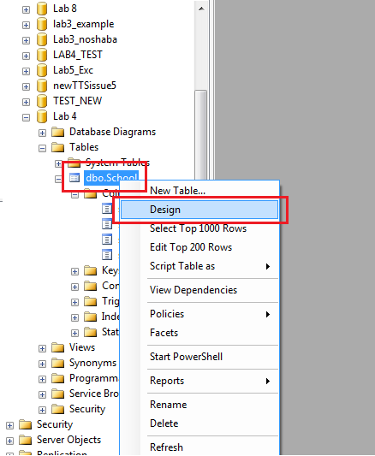

- Right Click on the column and choose “SET Primary KEY” .After selecting you will see a small key on the left side of selected column.
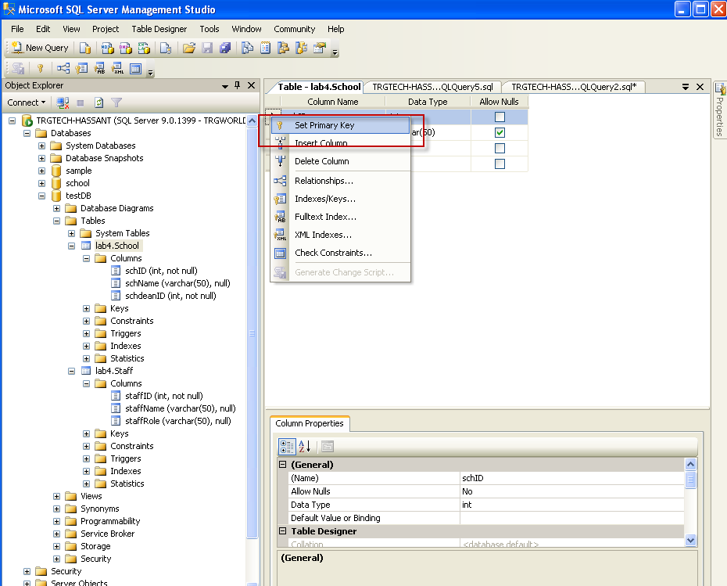

- Save the table and uncheck the value of Allow Nulls
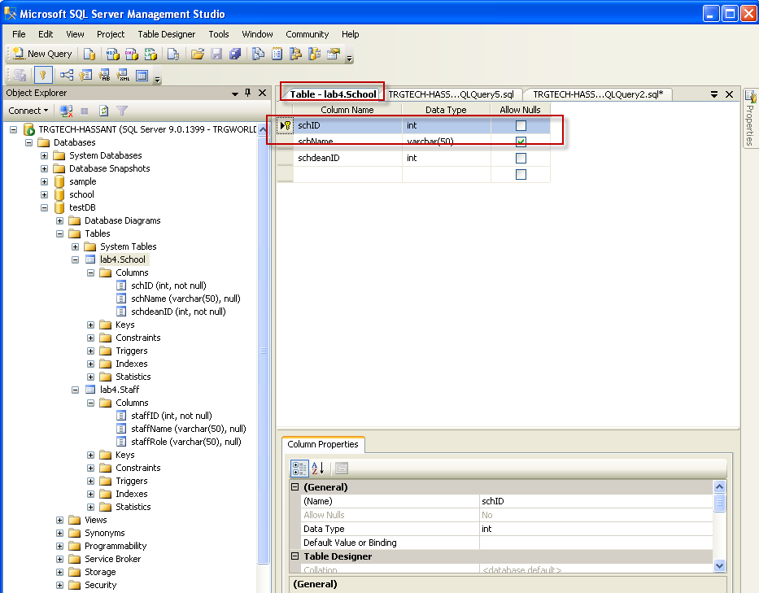

Step 2: PRIMARY KEY through Script
- Set Primary Key on Existing Table. Use ‘Alter’ keyword to make changes in the created table.
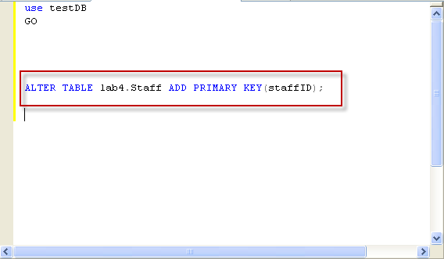

- 2. Verify from Designer
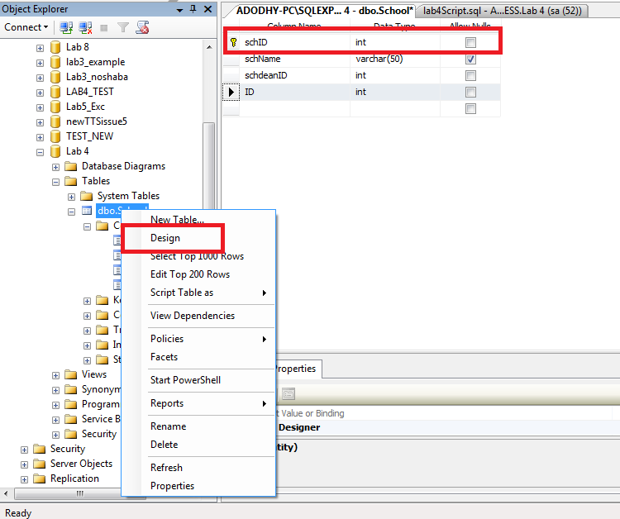

Step 3: PRIMARY KEY through Script
- Set Primary Key on New Table
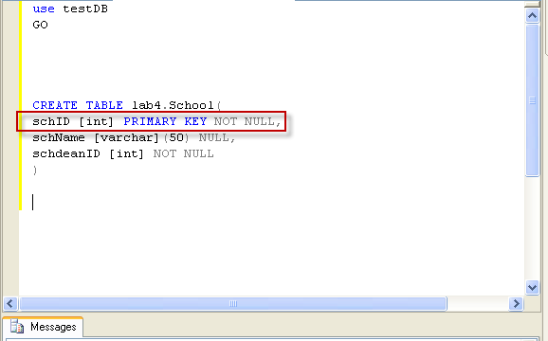

Task 8: SET IDENTITY COLOUMN using SQL server management studio designer | Estimated completion time (mins): 10
Step 1: IDENTITY COLUMN through Designer
- Right Click on School Table and Click on “Design”
- Add a new Column by Name of “SrNo”
- Choose “Identity Specification” and from “Is Identity” dropdown chosoe “Yes” and save
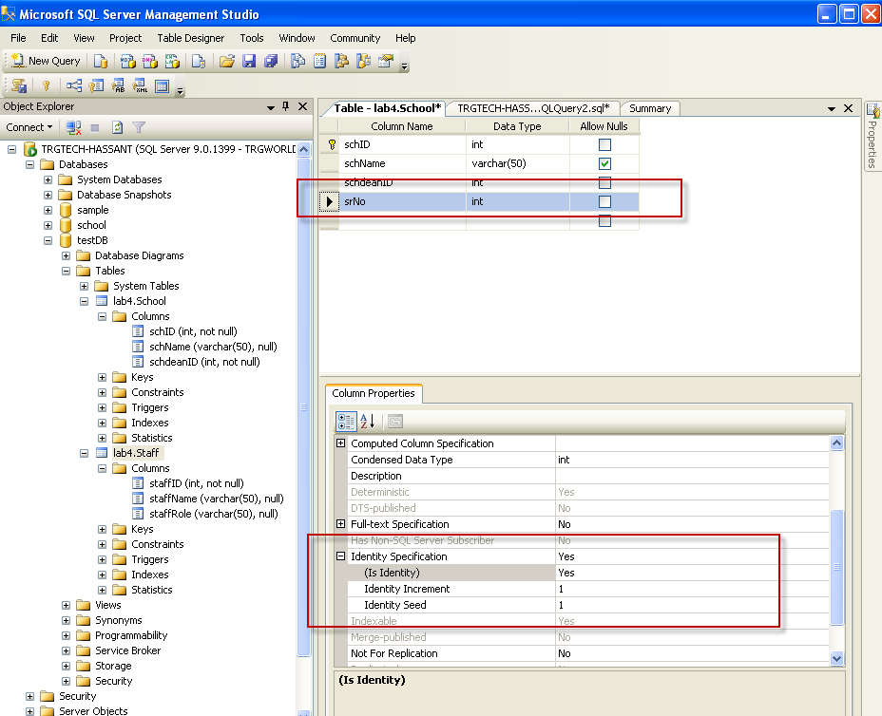

- Select * FROM lab4.School
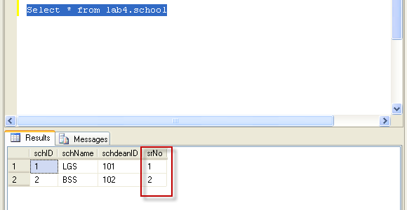

Step 2: IDENTITY COLUMN through Script
- Set Identity Column on Existing Table with new column name “SrNoStaff”

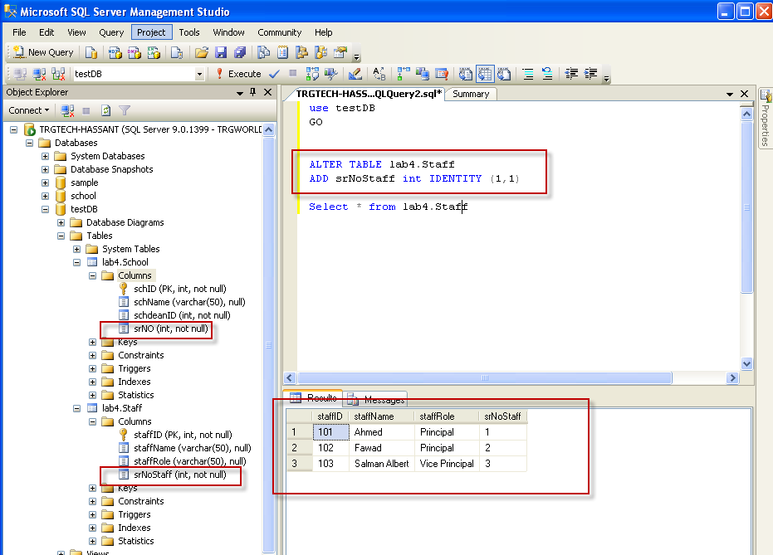

Step 3: IDENTITY COLUMN through Script on New Table
- Set Identity Column on New Table with new column name “schoolSrNo”
- 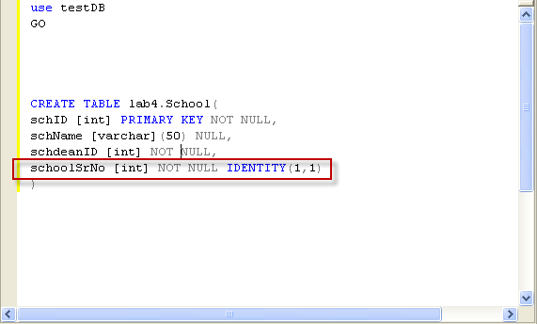

Foreign Key

Task 6: SET Foreign Key using SQL server management studio designer | Estimated completion time (mins): 15
Step 1: Foreign Key through Designer
- Right Click on School Table and Click on “Design”
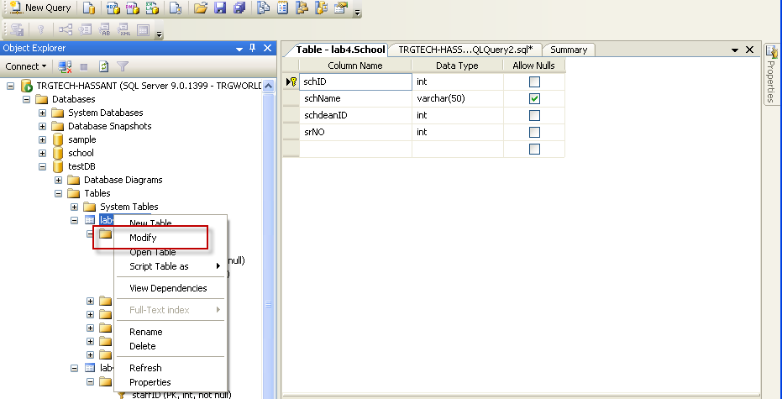
- Right Click on schDeanID and choose “relationships”
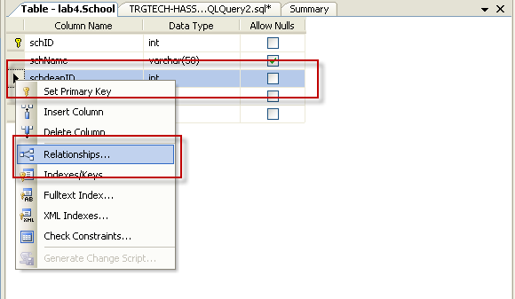

- Click on Add button
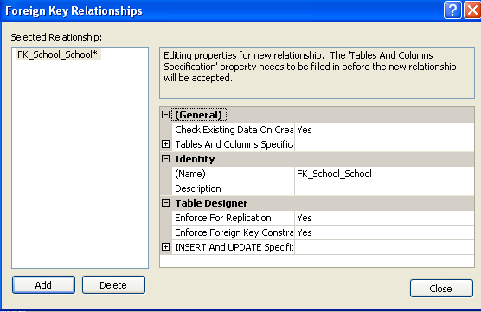
- Click edit button on Table and Column Specification
- 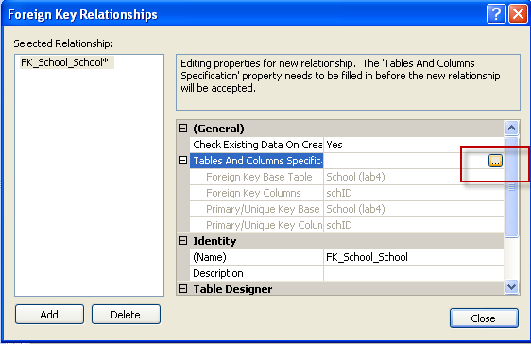
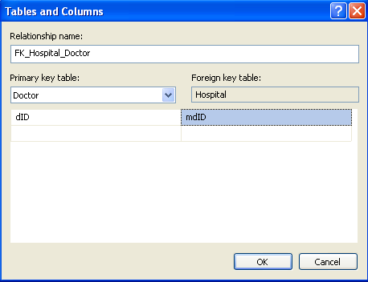

- Choose Primary Key Table to “Staff” and column below to “staffID” and from Foreign Key table choose schDeanID
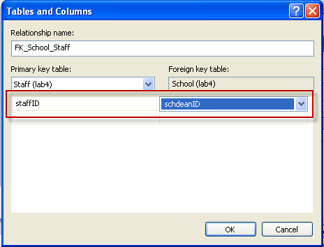

- Close
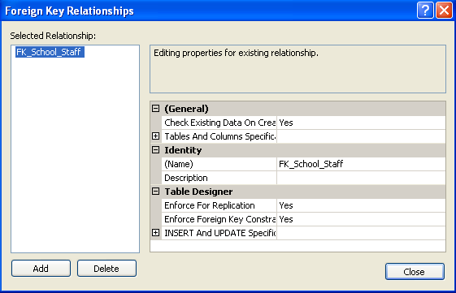

- Verify by inserting data from designer, before that delete all rows from table
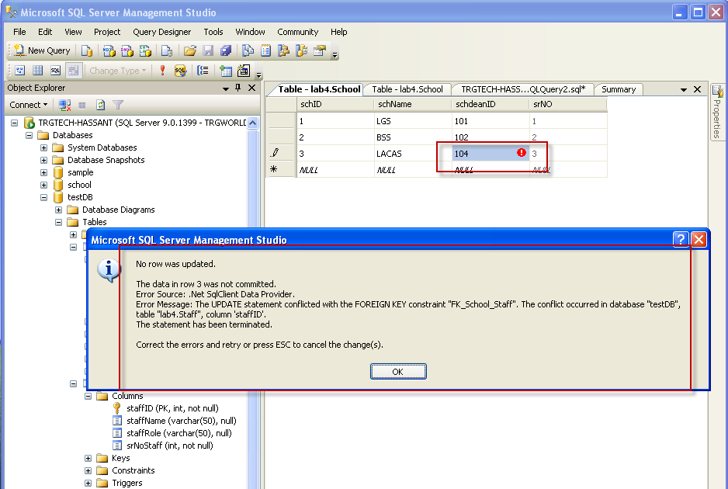
- Refrential Integrity Constraints
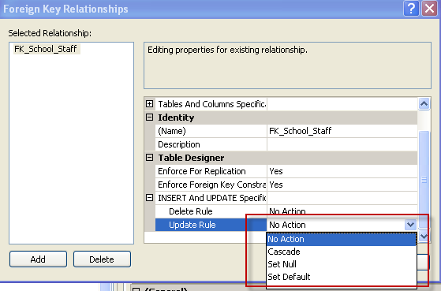

EXERCISE :

Q No 1 )
- Create Table Departments with column DepartmentID, DepartmentName, DeptHeadID with DepartmentID as primary key. Set the data types in accordance to real time scenario.
- Create Table Employees with column EmployeeID,EmployeeName with EmployeeID as primary key. Set the data types in accordance to real time scenario
- Alter Table Departments by adding new column DepartmentCode
- Insert at least five records in both table
- Alter Table Departments and add identity column by name of DepartmentSrNo
- Develop foreign key relation between two tables.
- Implement referential integrity constraint of Set Null on Delete Rule on above relationship
- Implement referential integrity constraint of Set Cascade on Update Rule on above relationship

Q No 2)
Let’s Create a simple database of University Campus which has multiple buildings. Each entity is distinguished on the basis of unique id and will also have foreign key relationships with its parent table.
- Create a Table ‘Campus’ with following attributes
Attribute Name Type

Campusid INTEGER(5) Primary Key NOT NULL,
CampusName VARCHAR(30) NOT NULL,
CampusAddress VARCHAR(50) NULL,
Country VARCHAR(20) NULL
City VARCHAR(20) NULL
isOpen BIT NOT NULL

- Create Table Buildings with following attributes
Attribute Name Type

Buildingid INTEGER(5) Primary Key NOT NULL
Buildingname VARCHAR2(30) NULL
Address VARCHAR2(30) NULL

- Implement the foreign key relationship between the two entities such that CampusID should appear as the Foreign Key in the Buildings table.
- Insert 5 different Buildings and Campuses of your own choice. Make sure that the primary keys are unique.
- Display all the campuses and buildings via query.
- At least add two Buildings in previous step such that they belong to the same campus and then write a SQL query to select them.
- Update a CampusName to “Campus1” via SQL query.
- Delete the campus added in the step (g) on the basis of CampusName.
- Implement referential integrity constraint of Set Null on Delete Rule on above relationship.
- Implement referential integrity constraint of Set Cascade on Update Rule on above relationship.

Note:
- For Part A to E, submit single sql file which contains sql command for each part
- For Part F to H, submit screen shots in one word file
- Zip the package by your roll number and submit

